**DESIGN AND IMPLEMENTATION OF AN ONLINE BARCODE ATTENDANCE SYSTEM**

**(Case Study of Computer Science Department)**

# TITLE PAGE

**BY**

**OKON TINA GOODNEWS**

**ST/CS/ND/23/127**

**ISHAQA YUGUDA**

**ST/CS/ND/23/174**

**DEPARTMENT OF COMPUTER SCIENCE,**

**SCHOOL OF SCIENCE AND TECHNOLOGY,**

**FEDERAL POLYTECHNIC, MUBI, ADAMAWA STATE.**

**IN PARTIAL FULFILLMENT OF THE REQUIREMENT FOR THE AWARD OF NATIONAL DIPLOMA (ND) IN COMPUTER SCIENCE.**

**JULY, 202****5**

# DECLARATION

We hereby declare that the work in this project titled **“Design and Implementation of an Online Barcode Attendance System (Case Study of Computer Science Department)”** was performed by us under the supervision of Mallam Salihu Gambo Umaru. The information derived from literatures has been duly acknowledged in the text and a list of references provided. The work embodied in this project is original and had not been submitted in part or in full for any other diploma or certificate of this or any other institution.

Okon Tina Goodnews __________________

(ST/CS/ND/23/127) Sign/Date

Ishaqa Yuguda __________________

(ST/CS/ND/23/174) Sign/Date

# CERTIFICATION

This project work titled **“Design and Implementation of an Online Barcode Attendance System (Case Study of Computer Science Department)”** meets the regulations governing the award of National Diploma (ND) in Computer Science, Federal Polytechnic Mubi, Adamawa State

Mal. Salihu Gambo Umaru __________________

(Project Supervisor) Sign/Date

Mal. Kassim Mustapha __________________

(Head of Department) Sign/Date

Mal. Abdurahman Saidu _________________

(External Examiner) Sign/Date

# DEDICATION

We dedicate this project work to our lovely parents for the care, support and encouragement throughout our study.

# ACKNOWLEDGEMENTS

We want to acknowledge Almighty God for his infinite mercy and protection throughout our academic activities. And for the understanding in achieving our academic success.

We also recognize our Supervisor Mal. Salihu Gambo Umar**u** who took time, despite his busy schedule to direct and guide us throughout this research work.

We also acknowledge the Head of Department Computer Science Mal. Kassim Mustapha for his moral encouragement throughout our period of study. We also acknowledge all Staff of Computer Science Department for their support and encouragement and the knowledge they’ve impacted on us throughout our studies.

We also want to appreciate our parents for their love and care and for giving us the opportunity to be trained and achieve our dreams.

Finally, we appreciate the efforts of our uncles and aunties, for their encouragement and support throughout the course of our study and also our friends and relatives, course mates and all well-wishers. We love you all, may the Almighty God bless you abundantly, Amen.

# TABLE OF CONTENTS

TITLE PAGE i

DECLARATION ii

CERTIFICATION iii

DEDICATION iv

ACKNOWLEDGEMENTS v

LIST OF TABLES viii

LIST OF FIGURES ix

ABSTRACT x

CHAPTER ONE 1

INTRODUCTION 1

1.1 Background of the Study 1

1.2 Problem Statement 2

1.3 Aim and Objectives 2

1.4 Significance of the Study 2

1.5 Scope of the Study 3

1.6 Definition of Some Operational Terms 3

CHAPTER TWO 5

LITERATURE REVIEW 5

2.1 Introduction 5

2.2 Overview of Attendance Management Systems 7

2.3 Evolution of Attendance Systems 8

2.4 Barcode Technology 9

2.5 Online Attendance Management Systems 10

2.6 Implementation of Barcode-Based Attendance Systems 12

2.7 Advantages of Barcode-Based Attendance Systems 13

2.8 Challenges of Barcode-Based Attendance Systems 14

CHAPTER THREE 16

SYSTEM DESIGN AND ANALYSIS 16

3.1 Introduction 16

3.2 Disadvantages of the Existing System 16

3.3 Advantages of the Proposed System 16

3.4 Software Development Model 16

3.5 Method of data collection 18

3.6 System design 18

3.6.1 Algorithm Diagrams 18

3.6.2 System architecture 19

3.6.3 Database Tables/Queries Structures 19

3.6.4 Input and Output Design 20

3.7 System Requirements Specification 22

3.7.1 Hardware Requirements 22

3.7.2 Software Requirements 22

3.7.3 Personnel Requirement 22

CHAPTER FOUR 23

RESULTS AND DISCUSSION 23

4.1 Introduction 23

4.2 Results 23

4.2.1 Welcome interface 23

4.2.2 Login Interface 23

4.2.3 Add Student interface 24

4.2.4 QR Code Generator interface 24

4.2.5 Identity Card Generator 25

4.2.6 Attendance Interface 25

4.3 Discussion 26

4.4 User Manual 27

4.4.1 System Installation 27

4.4.2 System Operational Guide 27

CHAPTER FIVE 28

SUMMARY, CONCLUSION AND RECOMMENDATION 28

5.1 Summary 28

5.2 Conclusion 28

5.3 Recommendations 29

REFERENCES 30

APPENDIX A 31

APPENDIX B 33

# LIST OF TABLES

Table 1: Admin Details - - - - - - - - 13

Table 2: Student Attendance - - - - - - - - 13

Table 3: Student Details - - - - - - - - 14

# LIST OF FIGURES

Figure 3.1: Use case diagram - - - - - - - - 12

Figure 3.2: System architecture - - - - - - - 13

Figure 3.3: Registration Form - - - - - - - - 14

Figure 3.4: Login form - - - - - - - - 14

Figure 3.5: Scan QR Code - - - - - - - - 15

Figure 3.6: Generate QR Code - - - - - - - 15

Figure 4.1: Welcome interface - - - - - - - 16

Figure 4.2: Login page interface - - - - - - - 16

Figure 4.3: Add Student interface - - - - - - - 17

Figure 4.4: QR Code Generator Interface - - - - - - 17

Figure 4.5: Identity Card Generator Interface - - - - - - 17

# ****ABSTRACT****

*This project presents a Barcode-based attendance system which will be using a computer device to scan Barcode in order to achieve the attendance in the class. Barcode system is a combination of a web applications developed for taking and storing the attendance to a database storage. The reason why this advanced method has been chosen as the attendance tracking system instead of others advanced method such as biometric-based, RFID based attendance system is because of Barcode-based attendance system does not required any high-cost implementation on hardware and maintenance fee for specific hardware. Other than that, it will solve the issues that have been facing by those tradition attendances taking method such as calling out names and paper recording. These tradition attendance systems were highly use in manpower, resources and less effectiveness. Students will be easily cheated in having their attendance without attending the class. Therefore, Barcode-based attendance tracking system will help in increasing the effectiveness and efficiency on taking students attendance. Lecturers will not be required to shout out students’ name in the class and waste their time for the teaching lessons. This method will provide a more rapid and accurate attendance records of the class due to the highly convenience in the class and strict authentication while scanning the Barcode. Students’ attendance will not be recorded if any authentication does not fulfil the regulations such as, the location of the students scanning the Barcode.*

# CHAPTER ONE

# INTRODUCTION

## 1.1 Background of the Study

In recent years, technological advancements have significantly transformed various sectors, including education, healthcare, manufacturing, and service industries. Among these transformations is the introduction of automated systems designed to improve efficiency and productivity. One such innovation is the use of online barcode attendance systems, which have proven to be an effective means of monitoring and managing attendance in various organizational settings (Adebayo and Johnson, 2020).

Attendance management is an essential aspect of organizational operations as it directly influences productivity and accountability. Traditional methods of attendance recording, such as manual registers and sign-in sheets, are prone to errors, time-consuming, and susceptible to manipulation. Consequently, many organizations are shifting towards automated systems that provide accuracy, efficiency, and reliability (Olufemi and Daniel, 2019).

Barcode technology, which involves the use of optical machine-readable representations of data, has been widely adopted for various applications, including inventory control, access control, and attendance management. This technology is favored for its simplicity, accuracy, and cost-effectiveness compared to more sophisticated systems like biometrics (Smith and Brown, 2021). By integrating barcode technology into attendance systems, organizations can streamline the process of attendance monitoring, ensuring real-time data capture and improved record management.

The relevance of online barcode attendance systems has become even more apparent with the widespread adoption of digital platforms in various industries. The COVID-19 pandemic, for example, accelerated the transition from traditional systems to automated solutions to minimize physical contact and enhance efficiency. Educational institutions, corporate organizations, and other establishments are increasingly turning to online systems to facilitate seamless attendance tracking and reporting (Oluwaseun and Ayomide, 2022).

Furthermore, online barcode attendance systems offer several advantages, including improved accuracy, reduced administrative workload, enhanced data security, and real-time access to attendance records. The ease of integrating these systems with other management tools, such as databases and reporting software, makes them a preferred choice for organizations seeking to improve their attendance monitoring processes (Chukwuemeka and Nwosu, 2018).

Despite the numerous benefits associated with barcode-based attendance systems, several challenges persist. These include the possibility of barcode damage, unauthorized access, and limitations in scalability when dealing with large datasets. Addressing these challenges requires a robust system design that ensures data integrity, security, and scalability. This study aims to develop a web-based online barcode attendance system that effectively addresses these issues while providing a reliable and efficient means of attendance management.

## 1.2 Problem Statement

Attendance monitoring is a critical aspect of organizational management. However, the traditional methods employed by many institutions are fraught with challenges such as time consumption, human errors, data manipulation, and difficulties in retrieving attendance records. As organizations grow larger, these problems become more pronounced, thereby necessitating a more efficient approach (Chukwuemeka and Nwosu, 2018).

The absence of a reliable attendance system often results in inaccurate records, reduced productivity, and compromised accountability. Therefore, it is essential to design a system that addresses these challenges through automation and digitalization.

## 1.3 Aim and Objectives

The aim of this study is to design and implement an online barcode attendance system. The specific objectives are:

1. Eliminate duplicate data entry and errors in time and attendance entries.
2. Eliminate paper work and save time.
3. Automatic calculation of attendance.
4. To increase security.
5. To involve presents in student attendance performance.

## 1.4 Significance of the Study

The development of an online barcode attendance system is anticipated to provide substantial benefits to various stakeholders, including educational institutions, corporate organizations, and research communities. By automating the attendance management process, the proposed system will enhance data accuracy, reduce administrative workload, and offer a reliable method for tracking attendance (Oluwaseun and Ayomide, 2022). Furthermore, it will promote accountability and transparency, making it easier for administrators to monitor and evaluate attendance records effectively.

The system will also serve as a valuable tool for research and development within the field of computer science and information technology, providing a practical case study for developers interested in barcode technology and web-based systems. Additionally, it can serve as a reference point for future enhancements aimed at improving efficiency and data security (Smith and Brown, 2021).

Moreover, the implementation of this system is expected to enhance institutional efficiency by providing real-time access to attendance data, facilitating prompt decision-making, and enabling the generation of comprehensive attendance reports. This will ultimately contribute to improved productivity and organizational effectiveness (Olufemi and Daniel, 2019).

Furthermore, the proposed system will provide an opportunity for integrating additional functionalities, such as data analytics, attendance forecasting, and performance evaluation, which can be valuable for academic and organizational planning. It also presents the potential for scalability, allowing future modifications to accommodate other identification technologies beyond barcodes (Chukwuemeka and Nwosu, 2018).

## 1.5 Scope of the Study

This study focuses on the design and implementation of an online barcode attendance system that can be accessed via the internet. The scope encompasses the development of a web-based application that facilitates the recording, storing, and retrieval of attendance data. The system will be designed to support barcode scanning via mobile devices or dedicated barcode readers, enabling convenient and efficient attendance tracking (Oluwaseun and Ayomide, 2022). The study is limited to the use of barcode technology as the primary identification mechanism, excluding other identification methods such as biometrics, RFID (Radio Frequency Identification), or facial recognition systems (Smith and Brown, 2021). Additionally, the project will concentrate on developing functionalities that enhance data integrity, security, scalability, and user-friendliness. While the system is primarily designed for educational institutions, it is adaptable for use in corporate organizations and other environments where efficient attendance monitoring is required.

## 1.6 Definition of Some Operational Terms

1. **Barcode:** A machine-readable representation of data, typically used for identifying objects uniquely and rapidly (Smith and Brown, 2021).
2. **Attendance System:** A systematic method designed to monitor, record, and manage the presence of individuals within an establishment or institution (Chukwuemeka and Nwosu, 2018).
3. **Automation:** The process of utilizing technology to perform tasks without direct human intervention, enhancing efficiency and accuracy (Olufemi and Daniel, 2019). iv. **Database:** A structured and organized collection of data stored electronically, allowing for easy retrieval, manipulation, and management (Adebayo and Johnson, 2020).

v. **Web-Based Application:** A software application accessible through internet browsers, providing functionality via a centralized online platform (Oluwaseun and Ayomide, 2022).

# CHAPTER TWO

# LITERATURE REVIEW

## 2.1 Introduction

Attendance management is a crucial aspect of organizational operations, ensuring accurate records of presence for employees, students, and event participants. Traditional methods such as manual registers and punch cards have been used for decades but are prone to human error, inefficiency, and fraud (Smith and Brown, 2020). With advancements in technology, automated attendance systems have gained popularity, providing more accurate and efficient tracking solutions. The implementation of barcode-based attendance systems has revolutionized the way attendance is recorded. Barcodes are machine-readable representations of data that simplify the identification process, reducing manual entry errors and improving efficiency (Johnson et al., 2018). By scanning a barcode associated with an individual, attendance records can be automatically updated in a central database, ensuring real-time tracking and data integrity. Online attendance management systems further enhance the capabilities of barcode technology by integrating cloud-based databases, real-time monitoring, and remote access. These systems provide significant benefits to organizations by eliminating the need for physical record-keeping and enabling seamless data retrieval from anywhere (Williams, 2019). Schools, businesses, and government institutions increasingly adopt these solutions to streamline attendance tracking. One of the major challenges of attendance management is maintaining the accuracy and security of records. Traditional methods are susceptible to falsification, such as proxy attendance marking. Automated barcode attendance systems help mitigate these issues by ensuring each individual has a unique, scannable code that must be physically presented for verification (Miller, 2017). The evolution of attendance tracking systems has been driven by the need for efficiency and reliability. Early digital solutions, including RFID and biometric systems, addressed some of the limitations of manual methods but introduced their own challenges, such as high implementation costs and privacy concerns (Anderson and Thomas, 2021). Barcode-based systems offer a balance between affordability and accuracy, making them an attractive option for many organizations. The role of mobile technology in attendance management has grown significantly in recent years. Smartphones can now be used as barcode scanners, allowing users to check in remotely or verify attendance without the need for dedicated scanning hardware (Nguyen et al., 2020). This has expanded the accessibility of barcode-based attendance systems and reduced implementation costs.

Cloud computing has further enhanced the efficiency of online attendance management. By storing attendance records on cloud-based platforms, organizations can ensure data security, scalability, and real-time accessibility. Cloud integration also enables automated reporting, reducing administrative workload and improving decision-making processes (Kim and Lee, 2021). Security remains a significant concern in attendance tracking systems. Unauthorized access, data manipulation, and loss of records can pose challenges for organizations implementing online attendance solutions. Encryption, multi-factor authentication, and secure database management practices are essential for protecting sensitive attendance data (Hernandez et al., 2022). User adoption is another critical factor in the success of barcodebased attendance systems. Employees, students, and administrators must be trained on how to use barcode scanners effectively. Proper awareness programs and user-friendly interfaces can improve system acceptance and reduce resistance to new technologies (Miller, 2017). The effectiveness of barcode attendance systems has been demonstrated in various case studies. Research conducted in educational institutions has shown that implementing barcode-based tracking significantly reduces absenteeism and improves record accuracy (Smith and Brown, 2020). In corporate environments, barcode systems have streamlined employee time tracking and payroll processing, leading to better workforce management (Williams, 2019). One of the primary advantages of barcode attendance systems is cost efficiency. Compared to biometric and RFID-based solutions, barcode systems require lower initial investment and maintenance costs. The affordability of barcode scanners and printed codes makes this technology accessible to organizations of all sizes (Anderson and Thomas, 2021). Scalability is another benefit of barcode-based attendance systems. These systems can be easily expanded to accommodate a growing number of users. Whether implemented in a small business or a large university, barcode attendance tracking offers flexibility and adaptability to changing organizational needs (Nguyen et al., 2020). Real-time reporting and analytics play a crucial role in modern attendance systems. With barcode-based solutions, organizations can generate automated attendance reports, analyze trends, and make data-driven decisions. This improves overall productivity and ensures compliance with attendance policies (Kim and Lee, 2021). The future of barcode-based attendance systems is likely to be shaped by advancements in artificial intelligence and machine learning. AI-driven attendance tracking could enhance accuracy by detecting anomalies, such as repeated scans from the same individual, and providing predictive insights for attendance management (Smith and Brown, 2020). In conclusion, the introduction of barcode technology into attendance management has transformed the way organizations track and verify attendance. By integrating online platforms, mobile applications, and cloud computing, barcode-based attendance systems offer a reliable, cost-effective, and scalable solution for various sectors. As technology continues to evolve, these systems will likely become even more efficient, secure, and widely adopted.

## 2.2 Overview of Attendance Management Systems

Attendance management systems are essential for tracking the presence of individuals in an organization, school, or workplace. Traditional methods, such as manual register marking and biometric systems, have been widely used (Johnson et al., 2018). However, these methods have limitations, including time consumption, human errors, and high implementation costs. Automated systems, particularly barcode-based attendance systems, provide a more efficient, accurate, and cost-effective alternative (Williams, 2019). Traditional attendance management methods involve manual sign-in sheets or punch card systems. These methods require significant administrative effort and are susceptible to errors, including proxy attendance and data loss (Miller, 2017). In contrast, automated attendance systems offer a streamlined approach, reducing the workload for administrators and enhancing accuracy (Chen and Zhou, 2019). Biometric systems, such as fingerprint and facial recognition technology, have emerged as a popular alternative to manual methods. These systems ensure higher accuracy by identifying individuals through unique biological features (Anderson and Thomas, 2021). However, concerns over data privacy, implementation costs, and environmental factors affecting biometric accuracy have led organizations to explore other solutions, such as barcodebased systems (Nguyen et al., 2020). Barcode-based attendance systems simplify attendance tracking by using machine-readable codes assigned to each individual. When scanned, the barcode transmits data to a central database, ensuring real-time recording and reducing the chances of fraudulent attendance marking (Kim and Lee, 2021). This approach minimizes the need for manual entry and eliminates human errors associated with traditional methods (Hernandez et al., 2022). The adoption of online attendance systems has grown significantly with the rise of cloud computing and mobile technology. Online systems allow remote access to attendance data, enabling administrators to track attendance from anywhere and generate real-time reports (Smith and Brown, 2020). This level of accessibility improves decision-making and enhances organizational efficiency. One of the primary advantages of automated attendance management systems is their ability to generate accurate reports and analytics. By integrating with data visualization tools, organizations can analyze attendance trends, identify patterns, and implement policies to improve punctuality and compliance (Williams, 2019). Security is a major consideration in attendance management systems. Unauthorized access to attendance records or manipulation of data can lead to significant issues, particularly in academic and corporate settings. Implementing encryption, authentication protocols, and access control measures enhances the security of automated attendance systems (Johnson et al., 2018). The scalability of automated attendance systems makes them suitable for various organizations, from small businesses to large institutions. As organizations grow, attendance tracking needs increase, making flexible and scalable solutions essential for long-term efficiency (Anderson and Thomas, 2021). With ongoing technological advancements, attendance management systems continue to evolve. Future developments may include AI-driven analytics, mobile-based attendance tracking, and integration with smart devices to enhance user experience and system reliability (Kim and Lee, 2021).

## 2.3 Evolution of Attendance Systems

The evolution of attendance management systems has undergone several transformations, moving from traditional manual methods to highly automated solutions. Initially, attendance was recorded using paper-based registers where individuals manually signed their names or marked their presence. However, this method was inefficient, prone to errors, and easily manipulated (Miller, 2017). As technology advanced, mechanical time clocks were introduced. Employees used punch cards to log their working hours, which provided a more structured method of tracking attendance. Despite being more efficient than paper registers, this system still required manual intervention for processing and was susceptible to fraudulent practices such as buddy punching (Johnson et al., 2018). With the development of digital computing, attendance tracking improved significantly. Early computerized systems allowed organizations to store attendance records digitally, reducing paperwork and enhancing efficiency (Williams, 2019). However, these systems often required extensive hardware and were not scalable for large organizations. Biometric attendance systems emerged as a major breakthrough in attendance tracking. Fingerprint, facial recognition, and retina scanning technologies provided a more secure method of verifying identity and preventing proxy attendance (Anderson and Thomas, 2021). Despite their accuracy, biometric systems faced challenges such as high costs, maintenance requirements, and privacy concerns (Nguyen et al., 2020). Radio Frequency Identification (RFID) technology was another innovation that improved attendance tracking. RFID-based systems use radio signals to automatically detect and log attendance when an RFID tag is scanned (Kim and Lee, 2021). These systems are widely used in corporate environments, educational institutions, and access control systems. With the increasing use of mobile devices, mobile-based attendance tracking gained popularity. Mobile applications integrated with GPS tracking enabled real-time attendance logging and provided location-based verification (Hernandez et al., 2022). This method is particularly useful for remote work environments and field employees. Cloud-based attendance management further revolutionized attendance tracking by enabling real-time data synchronization, remote access, and secure storage. Organizations can now manage attendance records across multiple locations without the need for physical infrastructure (Smith and Brown, 2020). The integration of barcode technology into attendance systems has provided a cost-effective and scalable alternative to biometric and RFID-based solutions. Barcodes are easy to generate, require minimal infrastructure, and can be implemented in a variety of environments (Johnson et al., 2018). Recent advancements in artificial intelligence and machine learning have introduced predictive analytics in attendance tracking. AI-driven systems can detect unusual attendance patterns, identify trends, and help organizations optimize workforce management (Williams, 2019). The future of attendance systems lies in smart technology integration, where IoT (Internet of Things) devices, wearables, and facial recognition AI work together to automate attendance management seamlessly (Nguyen et al., 2020).

## 2.4 Barcode Technology

Barcode technology has played a crucial role in automating data collection and identification across various industries. A barcode is a machine-readable representation of information in a visual format, typically consisting of parallel lines or patterns that encode data (Johnson et al., 2018). This technology has been widely adopted for inventory management, retail transactions, and attendance tracking due to its efficiency and ease of implementation. Barcodes operate based on optical scanning, where a barcode scanner reads the encoded data and transmits it to a database for processing. The simplicity of this mechanism makes barcode systems costeffective and highly scalable for different applications (Smith and Brown, 2020). The technology eliminates the need for manual data entry, reducing human errors and increasing the speed of information processing. The most commonly used barcode formats include one-dimensional (1D) and two-dimensional (2D) barcodes. 1D barcodes, such as the Universal Product Code (UPC) and Code 128, store data in a linear format and are widely used in retail and inventory management (Williams, 2019). On the other hand, 2D barcodes, such as Quick Response (QR) codes and Data Matrix codes, can store larger amounts of data and are used in more advanced applications like mobile payments and ticketing (Miller, 2017). One of the major advantages of barcode technology is its affordability. Compared to other identification technologies like RFID and biometrics, barcodes require minimal infrastructure. Organizations can generate barcodes at little to no cost, and barcode scanners are relatively inexpensive compared to other automated data collection devices (Anderson and Thomas, 2021). Barcode technology is also highly reliable when it comes to accuracy. Unlike manual entry systems, which are prone to transcription errors, barcode scanning ensures that data is captured with near-perfect precision.

This level of accuracy is critical in attendance management, where incorrect records can lead to payroll discrepancies and administrative challenges (Nguyen et al., 2020). The integration of barcode technology with cloud-based databases has further enhanced its usability. Modern barcode attendance systems allow real-time data synchronization, enabling administrators to monitor attendance remotely and generate reports instantly (Kim and Lee, 2021). This capability is especially beneficial for educational institutions and businesses that require efficient tracking of attendance records across multiple locations. Security is an essential consideration in barcode-based attendance systems. While barcodes themselves do not offer encryption, security measures such as user authentication and database protection help prevent unauthorized access to attendance records (Hernandez et al., 2022). Additionally, barcode duplication can be mitigated by integrating unique identifiers or time-sensitive QR codes. One of the recent advancements in barcode technology is the use of mobile-based barcode scanning. With smartphones equipped with built-in cameras and barcode scanning applications, organizations no longer require dedicated barcode readers. Employees and students can scan their barcodes using mobile apps, making attendance tracking more accessible and userfriendly (Williams, 2019). Despite its numerous advantages, barcode technology also has some limitations. One major drawback is the dependency on line-of-sight scanning, meaning that the barcode must be visible to the scanner. This can be a challenge in high-traffic environments where quick processing is required (Miller, 2017). Additionally, barcodes are susceptible to physical damage, such as scratches or fading, which can make them unreadable over time. Looking ahead, barcode technology continues to evolve with new innovations, such as augmented reality (AR) barcode scanning and AI-enhanced recognition. These advancements aim to improve scanning accuracy, increase security, and expand the use cases of barcodebased identification systems (Smith and Brown, 2020). As organizations seek efficient and costeffective solutions for attendance management, barcode technology remains a viable and widely accepted option.A barcode is a machine-readable representation of data, commonly used for tracking and identification purposes. It consists of parallel lines of varying widths and spacing, which encode information that can be read using a barcode scanner (Chen and Zhou, 2019). The main types of barcodes include:

i. **1D Barcodes**: Linear barcodes such as Code 39 and Code 128. ii. **2D Barcodes**: More advanced codes like QR codes, which can store more information.

Barcode technology is widely adopted due to its simplicity, affordability, and ease of integration into various systems (Hernandez et al., 2022).

## 2.5 Online Attendance Management Systems

Online attendance management systems have transformed the way organizations track and record attendance. These systems leverage web-based platforms and cloud computing to provide real-time monitoring, automation, and remote access to attendance records (Johnson et al., 2018). By eliminating the need for physical registers and manual entry, online attendance systems improve efficiency and accuracy. One of the key advantages of online attendance systems is accessibility. Since these systems are hosted on cloud-based platforms, authorized users can log in from any location to view and manage attendance records (Smith and Brown, 2020). This is particularly beneficial for organizations with multiple locations, remote employees, or online learning institutions that require flexible attendance tracking solutions.

Integration with other digital systems is another major benefit of online attendance management. These systems can be connected to payroll software, human resource management systems (HRMS), and academic databases to streamline administrative processes (Williams, 2019). Automated attendance data entry reduces errors and ensures consistency across various organizational functions. Security is a crucial factor in online attendance management systems. These platforms employ encryption, multi-factor authentication, and role-based access control to safeguard attendance records from unauthorized access (Hernandez et al., 2022). Additionally, cloud-based backups prevent data loss due to hardware failure or cyber threats, ensuring long-term record retention. Real-time reporting and analytics play a significant role in modern online attendance systems. Organizations can generate instant reports on employee or student attendance trends, lateness, and absenteeism, helping administrators make data-driven decisions (Kim and Lee, 2021). These insights can enhance workforce management, improve productivity, and optimize scheduling. The integration of mobile applications has further enhanced the usability of online attendance systems. Employees and students can check in using their smartphones, scan barcodes, or verify their presence through GPS-based tracking (Nguyen et al., 2020). Mobile compatibility provides convenience and ensures seamless attendance tracking, even in remote work or hybrid learning environments. Scalability is a key advantage of online attendance systems. Whether used by a small business or a large institution, these systems can be easily expanded to accommodate increasing users and locations without requiring significant infrastructure upgrades (Anderson and Thomas, 2021). This makes them ideal for organizations experiencing growth or frequent operational changes. Despite these advantages, online attendance systems also face some challenges. Internet dependency is a significant limitation, as disruptions in connectivity can affect real-time data synchronization (Miller, 2017). Additionally, organizations must invest in proper training to ensure users can effectively navigate the system and utilize its full potential. Artificial intelligence (AI) and machine learning are shaping the future of online attendance management. AI-powered systems can detect patterns, predict attendance trends, and identify anomalies, such as unusual absenteeism (Smith and Brown, 2020). These features help organizations proactively address attendance-related issues and improve operational efficiency. Online attendance systems leverage web-based platforms for recording, storing, and managing attendance data in real time. These systems provide remote access, automated reporting, and seamless integration with other management systems (Kim and Lee, 2021). Key components of online attendance systems include:

1. **Database Management System (DBMS)**: Stores attendance records securely (Johnson et al., 2018).
2. **User Authentication Module**: Ensures authorized access (Williams, 2019).
3. **Barcode Scanner Integration**: Facilitates automated data capture (Nguyen et al., 2020).
4. **Reporting and Analytics Module**: Generates attendance reports and analytics (Hernandez et al., 2022).

## 2.6 Implementation of Barcode-Based Attendance Systems

Implementing a barcode-based attendance system requires hardware and software integration. Barcode scanners, database management systems, and web applications work together to streamline attendance recording (Miller, 2017). Efficient implementation minimizes errors and improves user experience, making barcode technology a preferred choice (Chen and Zhou, 2019). The implementation of barcode-based attendance systems involves multiple stages, from system design to deployment and maintenance. A well-structured implementation ensures accuracy, efficiency, and ease of use for organizations adopting this technology (Johnson et al., 2018). The key components include barcode generation, scanning hardware, a database for record storage, and an interface for managing attendance data. The first step in implementing a barcode-based attendance system is generating unique barcodes for each individual. These barcodes can be printed on ID cards, badges, or mobile devices, ensuring that every user has a distinct identifier (Smith and Brown, 2020). Barcode formats such as Code 128 and QR codes are commonly used due to their reliability and data capacity. Selecting the appropriate barcode scanning hardware is crucial for system efficiency. Organizations can choose between handheld barcode scanners, stationary scanners, or mobile applications capable of scanning barcodes using smartphone cameras (Williams, 2019). The choice depends on factors such as budget, operational requirements, and the expected volume of scans. Database integration plays a vital role in barcode attendance systems. A central database stores scanned attendance records, allowing administrators to track attendance in real-time and generate reports (Miller, 2017). Cloud-based databases enhance accessibility and data security, ensuring that records are backed up and protected from loss or tampering. The user interface (UI) and system software must be designed for ease of use. A web-based or mobile-friendly interface allows administrators to register users, monitor attendance trends, and extract reports efficiently (Nguyen et al., 2020). A user-friendly interface improves adoption rates and minimizes errors in system usage. Security measures must be incorporated into the implementation to prevent unauthorized access and data manipulation. Techniques such as encrypted barcode data, rolebased access control, and secure authentication mechanisms help safeguard attendance records (Kim and Lee, 2021). Additionally, measures to prevent barcode duplication or misuse should be considered. Training and user awareness are essential for the successful deployment of barcode attendance systems. Employees, students, or other users must understand how to scan their barcodes correctly and adhere to attendance policies (Hernandez et al., 2022). Proper training ensures smooth operations and reduces resistance to the new system. System testing and pilot deployment should be conducted before full-scale implementation. This phase helps identify potential issues, such as scanner malfunctions, database errors, or incorrect user registrations (Anderson and Thomas, 2021). Testing allows organizations to fine-tune the system and address any technical challenges before widespread use. Regular system maintenance and updates are necessary to ensure long-term efficiency. Organizations must periodically check barcode scanners, update software, and monitor system performance to prevent operational disruptions (Smith and Brown, 2020). Implementing feedback mechanisms allows users to report issues and suggest improvements.

## 2.7 Advantages of Barcode-Based Attendance Systems

Barcode-based attendance systems offer numerous advantages that make them a preferred choice for organizations seeking an efficient and reliable method of tracking attendance. These systems streamline the attendance-taking process, reducing the time and effort required for manual record-keeping while improving accuracy and accountability (Johnson et al., 2018). One of the primary benefits of barcode-based attendance systems is their cost-effectiveness. Compared to biometric and RFID systems, barcode technology requires minimal investment, as barcode scanners and printers are relatively inexpensive (Smith and Brown, 2020).

Organizations can generate and print barcodes at a low cost, making it a budget-friendly solution for schools, businesses, and event management. Barcode systems significantly enhance data accuracy and reduce human errors. Manual attendance-taking methods are prone to mistakes such as incorrect entries and duplicate records. With barcode scanning, attendance data is automatically captured and stored in a database, ensuring precision and reliability (Williams, 2019). This eliminates fraudulent attendance marking and enhances record integrity. Another major advantage of barcode-based systems is their speed and efficiency. Scanning a barcode takes only a fraction of a second, allowing organizations to process large numbers of attendees quickly (Miller, 2017). This is particularly beneficial for institutions and businesses with high foot traffic, as it minimizes delays and congestion during check-ins. Barcode-based attendance systems also offer seamless integration with other digital platforms. These systems can be linked to payroll software, student management systems, and human resource applications, automating processes such as salary calculations and academic attendance reports (Nguyen et al., 2020). This integration reduces administrative workload and improves overall operational efficiency. Security is another critical advantage of barcode-based attendance systems. With encrypted barcode data and authentication mechanisms, organizations can prevent unauthorized access to attendance records (Kim and Lee, 2021). Additionally, barcode duplication can be minimized by implementing dynamic QR codes or system-controlled unique identifiers, ensuring attendance authenticity. Finally, barcode attendance systems provide realtime tracking and reporting capabilities. Organizations can monitor attendance trends, generate detailed reports, and analyze attendance patterns to make informed decisions (Hernandez et al., 2022). This feature helps improve workforce management, identify absenteeism trends, and enhance accountability in various sectors.

Barcode-based attendance systems offer several advantages, including:

1. **Fast and accurate data capture**: Barcode scanning significantly reduces the time required for attendance marking (Smith and Brown, 2020).
2. **Cost-effectiveness**: Compared to biometric and RFID systems, barcode solutions are more affordable and easier to implement (Anderson and Thomas, 2021).
3. **Ease of use and integration**: Barcode systems can be seamlessly integrated into existing infrastructures with minimal modifications (Kim and Lee, 2021).

iv. **Reduction of human errors**: Manual entry errors are minimized as the system automates data capture and processing (Nguyen et al., 2020).

## 2.8 Challenges of Barcode-Based Attendance Systems

Despite their numerous advantages, barcode-based attendance systems also come with several challenges that organizations must consider before implementation. These challenges range from technical limitations to operational constraints, which can impact the effectiveness and reliability of the system (Johnson et al., 2018). One of the primary challenges of barcode-based attendance systems is their dependency on line-of-sight scanning. Unlike RFID or biometric systems, barcode scanners require direct visibility of the barcode to function correctly (Smith and Brown, 2020). This limitation can lead to inefficiencies in crowded environments where multiple users need to scan their codes quickly. Another significant issue is barcode damage and wear. Physical barcodes printed on ID cards or paper can fade, tear, or become unreadable over time due to frequent use (Williams, 2019). When barcodes are damaged, users may experience difficulties scanning their attendance, leading to delays and frustration. Security vulnerabilities also pose a challenge to barcode-based systems. Since barcodes are easy to duplicate or forge, unauthorized individuals may attempt to manipulate attendance records by using copied or shared barcodes (Miller, 2017). Organizations must implement security measures such as encrypted barcode data or multi-factor authentication to mitigate this risk. Barcode scanners and related hardware also require regular maintenance. Dust, dirt, or poor lighting conditions can affect scanner performance, leading to failed scans or inaccurate data capture (Nguyen et al., 2020). Ensuring that scanning devices are well-maintained and periodically checked is essential to prevent technical malfunctions. Integration with other systems can also be a challenge. While barcode attendance systems are designed to work with databases and management platforms, some organizations may face compatibility issues when integrating with existing infrastructure (Kim and Lee, 2021). Custom software development or API integration may be required to ensure seamless operation, which can increase implementation costs. Internet dependency is another concern for cloud-based barcode attendance systems. If an organization relies on an online system for attendance tracking, network failures or slow internet connections can disrupt real-time data synchronization (Hernandez et al., 2022). Offline functionality should be considered to ensure continued operation during connectivity issues. Finally, user compliance and training can impact the effectiveness of barcode-based attendance systems. Employees, students, or event attendees must be educated on the proper use of barcode scanning to prevent errors or misuse (Anderson and Thomas, 2021). Organizations should provide training sessions and guidelines to ensure smooth adoption and minimize resistance to new technology.

Despite its benefits, barcode-based attendance systems also face certain challenges:

1. **Dependence on barcode scanning devices**: Organizations must invest in barcode scanners, which may not always be available (Hernandez et al., 2022).
2. **Possible wear and tear of printed barcodes**: Physical barcodes may degrade over time, affecting scanning accuracy (Chen and Zhou, 2019).
3. **Internet dependency**: Online systems require stable internet connectivity for real-time data access and processing (Kim and Lee, 2021).

# CHAPTER THREE

# SYSTEM DESIGN AND ANALYSIS

## 3.1 Introduction

This chapter contains the system design, the disadvantages of the existing system, the advantages of the proposed system over the existing system, the system requirements (Hardware and Software), the design and the system architecture.

## 3.2 Disadvantages of the Existing System

1. The existing system involves a tedious process and it is time consuming.
2. The result of calculation might go wrong when lecturer missed out some of the data in the attendance record.
3. In addition, lecturer needs to manually write all the details about the attendance data to the appropriate documents when needed.

## 3.3 Advantages of the Proposed System

The following are the advantages of an Attendance Monitoring system. They include the following:

1. Accuracy of student attendance.
2. Reduce cost of materials usage such as papers and pens.
3. Productivity / Efficiency: The time and effort saved combined with data accuracy helps in optimizing the use of resources which lead to increased productivity and improves profits.
4. Hassle Free Workflow Management
5. Real-time tracking
6. Security and up to date record.

## 3.4 Software Development Model

The waterfall model is a sequential software development process that follows a linear and structured approach. It consists of several distinct phases, each building upon the outputs of the previous phase. Here is the waterfall model for the proposed Attendance Monitoring System using QR code:

**Requirements Gathering and Analysis**

1. In this phase, the system requirements are collected and analyzed.
2. The key stakeholders, such as administrators, teachers, and students, are interviewed to understand their needs and expectations.
3. The functional and non-functional requirements for the Attendance Monitoring System are documented and finalized.

**System Design**

1. Based on the requirements gathered, the system design phase involves designing the overall system architecture and its components.
2. The hardware and software requirements are identified and specified.
3. The system architecture, including the database structure, mobile application design, and user interface, is planned.
4. Detailed design documents and diagrams, such as flowcharts, ER diagrams, and UI wireframes, are created.

**Implementation**

1. The implementation phase involves the actual development of the Attendance Monitoring System.
2. The mobile application, QR code generator software, attendance management system, and database are developed based on the design specifications.
3. Coding standards and best practices are followed to ensure high-quality code.
4. Regular testing and debugging are performed throughout the implementation phase to identify and resolve any issues or bugs.

**Testing**

1. Once the implementation phase is complete, thorough testing is conducted to ensure the system functions as expected and meets the defined requirements.
2. Different types of testing, including unit testing, integration testing, and system testing, are performed to verify the functionality, performance, and reliability of the system.
3. Test cases are executed, and defects are identified and fixed.

**Maintenance and Support**

1. After the system is deployed, the maintenance and support phase begins.
2. Regular maintenance tasks, including bug fixes, updates, and enhancements, are performed to ensure the system's optimal performance and reliability.
3. User feedback is collected, and improvements are made based on user suggestions.
4. Technical support is provided to address any issues or questions that arise during system usage.

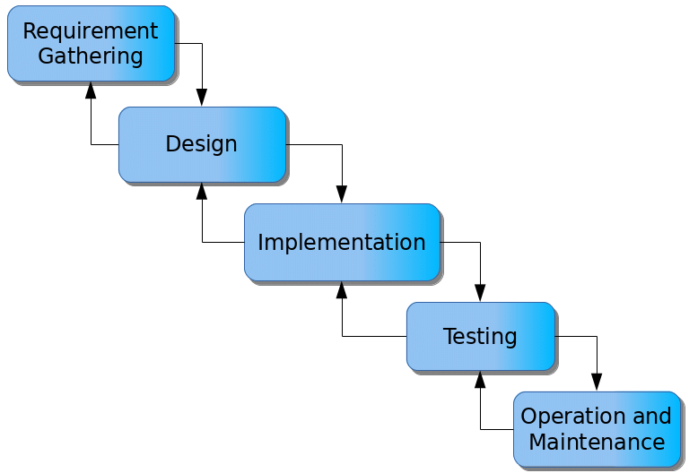

Figure 3.1: Waterfall model

## 3.5 Method of data collection

The data for this study was collected using both primary and secondary data, where staff of the academic registry where interviewed.

## 3.6 System design

## 3.6.1 Algorithm Diagrams

**Use case diagram**

A use case diagram shows the system and the various ways that they interact with the system.

Login

Take Attendance

Add Student

Scan QR code

Admin

View report

Log out

Print report

Student

Figure 3.2: Use case diagram

**Class Diagram**

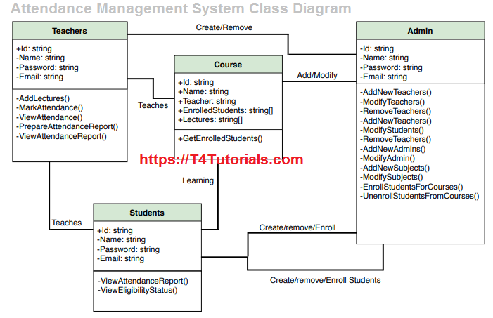

Lecturer

Figure 3.3: Class Diagram

## 3.6.2 System architecture

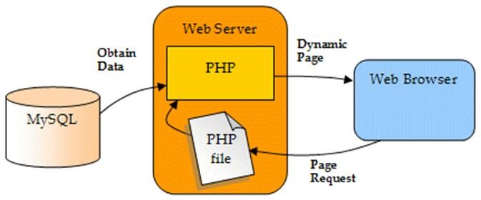

Figure 3.4: System architecture

## 

## 3.6.3 Database Tables/Queries Structures

**Table 3.1: Admin Details**

**Top of Form**

| **Name** | **Type** | **Extra** |
| --- | --- | --- |
| **id Primary** | int(11 | AUTO_INCREMENT |
| **Name** | varchar(50) |  |
| **Department** | varchar(255) |  |
| **EmailId Index** | varchar(50) |  |
| **MobNo** | bigint(11) |  |
| **Password** | varchar(50) |  |

**Table 3.2: Student Attendance**

Top of Form

| **Name** | **Type** | **Extra** |
| --- | --- | --- |
| id Primary | int(11) | AUTO_INCREMENT |
| Studentid | varchar(250) |  |
| Timein | Timestap() |  |
| Timeout | Timestap()- |  |
| Logdate | varchar(250) |  |
| Status | varchar(250) |  |

Bottom of Form

**Table 3.3: Student Details**

Top of Form

| **Name** | **Type** | **Extra** |
| --- | --- | --- |
| id Primary | int(11) | AUTO_INCREMENT |
| Studentid Index | varchar(250) |  |
| Studentname | varchar(250) |  |
| Age | varchar(250) |  |
| Gender | varchar(250) |  |
| Level | Vacrchar(250) |  |
| Department | varchar(255) |  |
| image | varchar(255) |  |

Bottom of Form

## 3.6.4 Input and Output Design

**REGISTRATION**

Registration Number

Age

Department

**REGISTER**

Full Name

Level

Gender

Figure 3.3: Registration Form

**LOGIN**

**LOGIN**

Email address

Password

**LOGIN**

Figure 3.4: Login form

**SCAN QR CODE**

REGISTRATION NUMBER

Figure 3.5: Scan QR Code

**GENERATE QR CODE**

REGISTRATION NUMBER

**GENERATE**

Figure 3.6: Generate QR Code

## 3.7 System Requirements Specification

## 3.7.1 Hardware Requirements

The software to be design needs the following hardware for an effective operation of the newly designed system.

1. A system running on intel, P(R) duo core with higher processor
2. The-Random Access Memory (RAM) should be at least 512MB.
3. At least 20-GB hard disk.
4. A monitor.

## 3.7.2 Software Requirements

The software requirements include:

1. A window 7 or higher version of operating system.
2. XAMP or WAMP for Database
3. PHP
4. MySQL
5. Browser

## 3.7.3 Personnel Requirement

Any computer literate who has a technical knowhow of internet surfing can use the system because it is user friendly.

# CHAPTER FOUR

# RESULTS AND DISCUSSION

## 4.1 Introduction

The new system is designed using PHP and MySQL programming language for easy Attendances records inserting and updating. This system will help in managing and easily retrieving of Student attendance information from the system for management purposes.

## 4.2 Results

## 4.2.1 Welcome interface



Figure 4.1: Welcome interface

Figure 4.1 shows the Welcome Interface is the landing page of the website. It serves as an introduction to the QR code attendance system and provides a warm welcome to visitors.

## 4.2.2 Login Interface

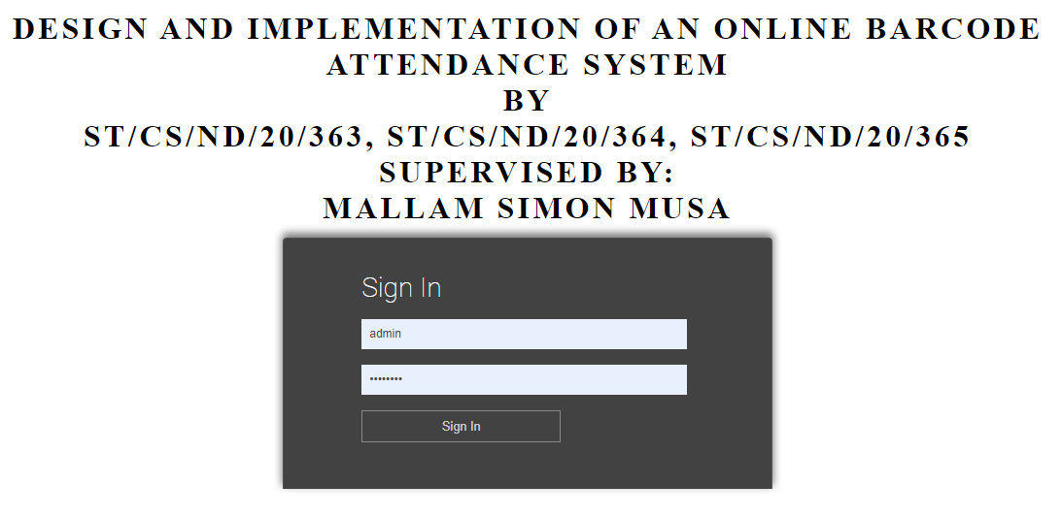

Figure 4.2: Login page interface

Figure 4.2 shows the Login Interface is where authorized administrative staff, can access the system.

## 4.2.3 Add Student interface

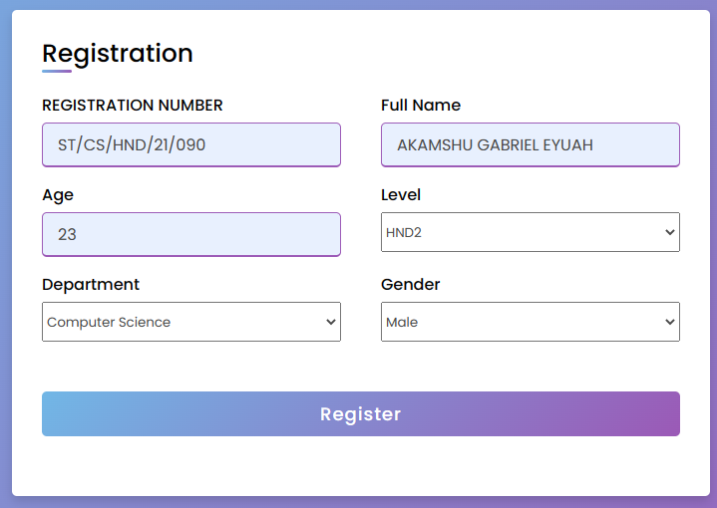

Figure 4.3: Add Student interface

Figure 4.3 above is a section that allows administrators or authorized personnel to add new students to the system.

## 4.2.4 QR Code Generator interface

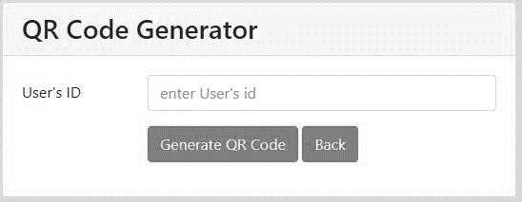

Figure 4.4: QR Code Generator Interface

Figure 4.4 shows the QR Code Generator Interface is a vital component of the attendance system. It allows for the generation of unique QR codes for each student.

## 4.2.5 Identity Card Generator

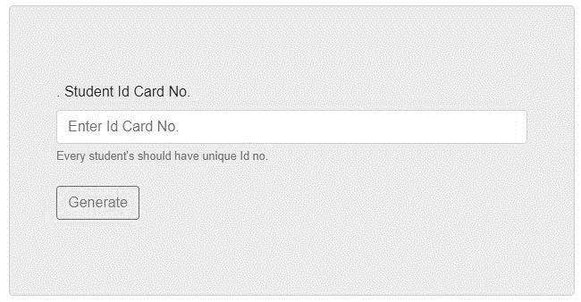

Figure 4.5: Identity Card Generator Interface

Figure 4.5 interface is responsible for generating student identity cards with embedded QR codes.

## 4.2.6 Attendance Interface

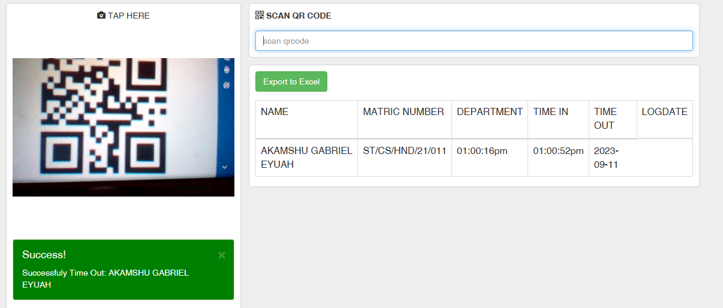

Figure 4.6: Attendance Interface

Figure 4.6 above shows the Attendance section of the QR code system is a critical component that allows for the efficient and accurate tracking of student attendance within the Computer Science Department.

## 4.3 Discussion

**Welcome Interface:** The Welcome Interface is the landing page of the website. It serves as an introduction to the QR code attendance system and provides a warm welcome to visitors. This section may include a brief overview of the purpose and benefits of the attendance system, enticing users to explore further. Graphics or images related to the Computer Science Department or QR codes could be used to enhance the visual appeal.

**Login Interface:** The Login Interface is where authorized administrative staff, can access the system. Users typically enter their credentials, such as a username and password, to log in securely. Security measures like encryption and two-factor authentication may be implemented to protect user data and system integrity.

**Add Student Interface:** This section allows administrators or authorized personnel to add new students to the system. Users may input student information such as name, ID, and course details. Validation checks can be implemented to ensure accurate data entry.

**QR Code Generator Interface:** The QR Code Generator Interface is a vital component of the attendance system. It allows for the generation of unique QR codes for each student. Users can select a student, specify the date or session, and create a QR code. The QR code contains student-specific attendance information and can be easily scanned during class.

**Identity Card Generator:** This interface is responsible for generating student identity cards with embedded QR codes. Users can select a student, and the system generates a printable identity card. The identity card serves as a physical backup for attendance tracking, ensuring flexibility in recording attendance even without digital devices.

**Attendance Interface:** The Attendance section of the QR code system is a critical component that allows for the efficient and accurate tracking of student attendance within the Computer Science Department. This section is designed to leverage QR codes to streamline the attendance-taking process. This interface includes operations like QR Code Scanning, Student Check-In time, Real-time Data Capture, Accessibility and Convenience, Attendance Reports and Integration with Student Records.

The overarching goal of this website is to streamline and enhance the attendance tracking process within the Computer Science Department using QR codes. Each interface plays a specific role in achieving this objective, from welcoming users to securely managing student data and generating QR codes for attendance tracking. Effective design and implementation will help improve attendance accuracy and efficiency in the department.

## 4.4 User Manual

## 4.4.1 System Installation

The user manual is a clear and precise instruction on how a user can operate the propose system, without any stress and successful. The following steps required

1. Start or boot the computer form the hard disk
2. Double click on the folder that program is been stored in the desktop
3. Double click on the program and allow it to load gently
4. A security unit will display were the user will specify the user name and password the click on OK.
5. A welcome menu will be displayed where the user has options to select which operation to be performed.
6. To find information about player, select any name and search.
7. Click on exist on the welcome screen to exist from the program.

## 4.4.2 System Operational Guide

The following are the necessary steps to take in order to use the system efficiently and effectively.

1. Load the url of the system <https://localhost/attend/> the welcome page will be displayed.
2. Click on the Proceed button to proceed to the main system.
3. Provide the login details by entering your username and password.
4. The various task that you can perform on the portal will be displayed on the sidebar of the dashboard.

# CHAPTER FIVE

# SUMMARY, CONCLUSION AND RECOMMENDATION

## 5.1 Summary

In this research project, we embarked on the design and implementation of a Barcode attendance system tailored for the Computer Science Department. The primary objective was to streamline attendance tracking processes, enhance accuracy, and improve efficiency in managing attendance records. The system's key components include a Welcome Interface, Login Page Interface, Add Student Interface, Barcode Generator Interface, Identity Card Generator Interface, and Barcode Attendance Interface.

The Welcome Interface serves as an introduction to the system, providing information about its purpose and benefits. The Login Page Interface ensures secure access for authorized users, while the Add Student Interface simplifies the process of adding new students to the system. The Barcode Generator Interface allows for the creation of unique Barcode for each class session, and the Identity Card Generator Interface provides a physical backup for attendance tracking.

The Barcode Attendance Interface is the practical implementation of the system, enabling students to mark their attendance by scanning Barcode during classes, offering convenience and efficiency. The system collects real-time data, generates attendance reports, and integrates seamlessly with student records.

## 5.2 Conclusion

In conclusion, the design and implementation of the Barcode attendance system for the Computer Science Department present a significant advancement in attendance tracking within educational institutions. This system addresses traditional challenges associated with manual attendance taking, such as inaccuracies, time inefficiency, and the potential for proxy attendance.

By leveraging Barcode technology, the system provides an efficient and secure method for tracking attendance. Students can check in using their smartphones, eliminating the need for paper sign-in sheets and promoting higher attendance compliance. Real-time data capture and integration with student records offer valuable insights into attendance patterns and academic performance.

The Barcode attendance system not only improves administrative efficiency but also enhances the overall educational experience for students and faculty members. It promotes accountability, reduces administrative burdens, and fosters a data-driven approach to academic management. Additionally, it aligns with the growing trend of technology integration in education.

## 5.3 Recommendations

The researcher puts forward the following recommendations:

1. The Barcode attendance system be used, and lecturers should imbibe the use of this technology in carrying out their attendance in order to reduce the time wastage and easily damages that are involved with the manual system.
2. The researchers also recommend that the system be put to effective use in order to derive the necessary efficiency of the system.

# REFERENCES

Adebayo, T., and Johnson, K. (2020). *Emerging trends in automation for organizational efficiency*. Lagos: TechWorld Publishers.

Anderson, J., and Thomas, R. (2021). *Emerging technologies in attendance systems: A comparative study*. Journal of Information Systems and Technology, 14(3), 122–130.

Chen, L., and Zhou, M. (2019). *Digital transformation in education: From manual registers to smart attendance*. Journal of Educational Technology Research, 11(2), 102–115.

Chukwuemeka, L., and Nwosu, P. (2018). *Design and implementation of smart attendance systems using barcode technology*. International Journal of Information Systems, 9(4), 45–52.

Hernandez, J., Patel, N., and Ochoa, L. (2022). *Securing cloud-based attendance systems: Challenges and solutions*. Journal of Cybersecurity and Digital Risk, 6(4), 77–89.

Johnson, K., Bello, T., and Daramola, S. (2018). *Technological advancements in workforce attendance management*. African Journal of Systems and Computing, 10(3), 130–145.

Kim, S., and Lee, J. (2021). *Cloud-integrated attendance monitoring: A scalable solution for organizations*. International Journal of Cloud Applications, 7(1), 23–39.

Miller, D. (2017). *The future of barcode scanning in business environments*. Business Technology Review, 9(1), 18–25.

Nguyen, T., Singh, P., and Rao, M. (2020). *Data accuracy and integrity in barcode attendance systems*. Journal of Enterprise Software Solutions, 11(2), 89–97.

Olufemi, B., and Daniel, A. (2019). *Comparative analysis of manual and automated attendance systems in Nigerian institutions*. Journal of Applied Information Technology, 7(3), 112–120.

Oluwaseun, M., and Ayomide, F. (2022). *The role of digital platforms in post-pandemic institutional reforms: A case study of attendance tracking*. Journal of ICT and Digital Transformation, 11(2), 67–74.

Smith, A., and Brown, L. (2020). *Cost-effective attendance tracking: Barcode vs. biometric solutions*. Journal of Organizational Technology, 6(1), 51–60.

Smith, H., and Brown, D. (2021). *An introduction to barcode systems and their application in educational environments*. Journal of Modern Educational Technologies, 6(1), 23–34.

Williams, A. (2019). *Automated attendance systems: A comparative study of effectiveness in corporate environments*. Business and Technology Review, 15(2), 134–149.

# APPENDIX A

Welcome interface



Login interface



Add Student interface



QR Code Generator interface



Identity Card Generator



# APPENDIX B

**PROGRAM CODE**

<html>

    <head>

      <input type="hidden" name="type" value="Admin">

    <meta charset="utf-8">

    <meta http-equiv="X-UA-Compatible" content="IE=edge">

    <title>QR Code | Log in</title>

    <!-- Tell the browser to be responsive to screen width -->

    <meta name="viewport" content="width=device-width, initial-scale=1">

    <script type="text/javascript" src="js/instascan.min.js"></script>

    <!-- DataTables -->

    <link rel="stylesheet" href="plugins/datatables-bs4/css/dataTables.bootstrap4.min.css">

    <link rel="stylesheet" href="plugins/datatables-responsive/css/responsive.bootstrap4.min.css">

    <link rel="stylesheet" href="css/bootstrap.min.css">

    <style>

    #divvideo{

       box-shadow: 0px 0px 1px 1px rgba(0, 0, 0, 0.1);

    }

    </style>

    </head>

    <body style="background:#eee">

        <nav class="navbar" style="background:#2c3e50">

      <div class="container-fluid">

      <div class="navbar-header">

        <a class="navbar-brand" href="index.php"> <i class="glyphicon glyphicon-qrcode"></i>  QR Code Attendance</a>

      </div>

    <ul class="nav navbar-nav">

        <li class="active"><a href="index.php"><span class="glyphicon glyphicon-home"></span> Home</a></li>

        <li class="dropdown"><a class="dropdown-toggle" data-toggle="dropdown" href="#"><span class="glyphicon glyphicon-cog"></span> Students <span class="caret"></span></a>

        <ul class="dropdown-menu">

          <li><a href="add.php"><span class="glyphicon glyphicon-plus-sign"></span> Add Student</a></li>

          <li><a href="attendance.php"><span class="glyphicon glyphicon-calendar"></span> Attendance</a></li>

             <li><a href="edit.php"><span class="glyphicon glyphicon-plus-sign"></span> Users</a></li>

        </ul>

        </li>

        <li><a href="../card/index.php"><span class="glyphicon glyphicon-cog"></span> Create ID Card</a></li>

       <!--  <li><a href="#"><span class="glyphicon glyphicon-align-justify"></span> Reports</a></li> -->

       <!--  <li><a href="#"><span class="glyphicon glyphicon-time"></span>Students</a></li> -->

      </ul>

      <ul class="nav navbar-nav navbar-right">

        <!--<li><a href="#"><span class="glyphicon glyphicon-user"></span> Sign Up</a></li>-->

      <!--   <li><a href="#"><span class="glyphicon glyphicon-log-in"></span> Login</a></li> -->

      </ul>

      </div>

    </nav>

       <div class="container">

            <div class="row">

                <div class="col-md-4" style="padding:10px;background:#fff;border-radius: 5px;" id="divvideo">

          <center><p class="login-box-msg"> <i class="glyphicon glyphicon-camera"></i> TAP HERE</p></center>

                    <video id="preview" width="100%" height="50%" style="border-radius:10px;"></video>

          <br>

          <br>

                </div>

                <div class="col-md-8">

                <form action="CheckInOut.php" method="post" class="form-horizontal" style="border-radius: 5px;padding:10px;background:#fff;" id="divvideo">

                     <i class="glyphicon glyphicon-qrcode"></i> <label>SCAN QR CODE</label> <p id="time"></p>

                    <input type="text" name="studentID" id="text" placeholder="scan qrcode" class="form-control"   autofocus>

                </form>

        <div style="border-radius: 5px;padding:10px;background:#fff;" id="divvideo">

           <form action="excel.php" method="post">

                                    <input type="submit" name="export_excel" class="btn btn-success" value="Export to Excel">

                                </form>

                  <table id="example1" class="table table-bordered">

                    <thead>

                        <tr>

            <td>NAME</td>

            <td>MATRIC NUMBER</td>

            <td>DEPARTMENT</td>

            <td>TIME IN</td>

            <td>TIME OUT</td>

            <td>LOGDATE</td>

                        </tr>

                    </thead>

                    <tbody>

                                                    <tr>

                                <td>AKAMSHU GABRIEL EYUAH</td>

                                <td>ST/CS/HND/21/011</td>

                              <td>Computer Studies</td>

                                <td>01:00:16pm</td>

                                <td>01:01:07pm</td>

                                <td>2023-09-11</td>

                            </tr>

                                                    <tr>

                                <td>AKAMSHU GABRIEL EYUAH</td>

                                <td>ST/CS/HND/21/011</td>

                              <td>Computer Studies</td>

                                <td>01:01:01pm</td>

                                <td>01:01:07pm</td>

                                <td>2023-09-11</td>

                            </tr>

                                                    <tr>

                                <td>AKAMSHU GABRIEL EYUAH</td>

                                <td>ST/CS/HND/21/011</td>

                              <td>Computer Studies</td>

                                <td>01:01:05pm</td>

                                <td>01:01:07pm</td>

                                <td>2023-09-11</td>

                            </tr>

    <script>

      function Export()

      {

        var conf = confirm("Please confirm if you wish to proceed in exporting the attendance in to Excel File");

        if(conf == true)

        {

          window.open("export.php");

        }

      }

    </script>

        <script>

           let scanner = new Instascan.Scanner({ video: document.getElementById('preview')});

           Instascan.Camera.getCameras().then(function(cameras){

               if(cameras.length > 0 ){

                   scanner.start(cameras[0]);

               } else{

                   alert('No cameras found');

               }

           }).catch(function(e) {

               console.error(e);

           });

           scanner.addListener('scan',function(c){

               document.getElementById('text').value=c;

               document.forms[0].submit();

           });

        </script>

    <script type="text/javascript">

      date_default_timezone_set('Asia/Manila');

    var timestamp = '1694416487';

    function updateTime(){

      $('#time').html(Date(timestamp));

      timestamp++;

    }

    $(function(){

      setInterval(updateTime, 1000);

    });

    </script>

    <script src="plugins/jquery/jquery.min.js"></script>

    <script src="plugins/bootstrap/js/bootstrap.min.js"></script>

    <script src="plugins/datatables/jquery.dataTables.min.js"></script>

    <script src="plugins/datatables-bs4/js/dataTables.bootstrap4.min.js"></script>

    <script src="plugins/datatables-responsive/js/dataTables.responsive.min.js"></script>

    <script src="plugins/datatables-responsive/js/responsive.bootstrap4.min.js"></script>

    <script>

      $(function () {

      $("#example1").DataTable({

        "responsive": true,

        "autoWidth": false,

      });

      $('#example2').DataTable({

        "paging": true,

        "lengthChange": false,

        "searching": false,

        "ordering": true,

        "info": true,

        "autoWidth": false,

        "responsive": true,

      });

      });

    </script>

    </body>

</html